

Project Name:

Google Translate Web Application

**Test Summary Report**

Test done by: W Shanali Nipunika Fernando

Test Start Date: 16/02/2024

Test End Date: 18/02/2024

**Table of Contents**

Introduction: 1

Testing Activities: 1

Manual Testing: 1

Load Testing: 2

Testing Results: 4

Functionality Testing: 4

UI Testing: 4

Translation Accuracy: 4

Performance Testing: 4

Issues Identified: 4

Recommendations: 5

Conclusion: 5

# **Introduction:**

The test summary report provides an overview of the testing activities conducted on the Google Translate web application. The testing encompassed manual testing on various devices, including laptops, Android, and macOS mobile devices, as well as some load testing using JMeter. The aim was to evaluate the functionality, usability, and performance of the web application across different platforms.

# **Testing Activities:**

## **Manual Testing:**

Tested the web application's functionality, including text translation, image translation, document translation, and website translation.

Evaluated the user interface (UI) across different devices to ensure consistency and usability.

Verified the accuracy and reliability of translations in English, Sinhala, and Tamil languages.

Conducted exploratory testing to uncover any hidden issues or unexpected behaviors.

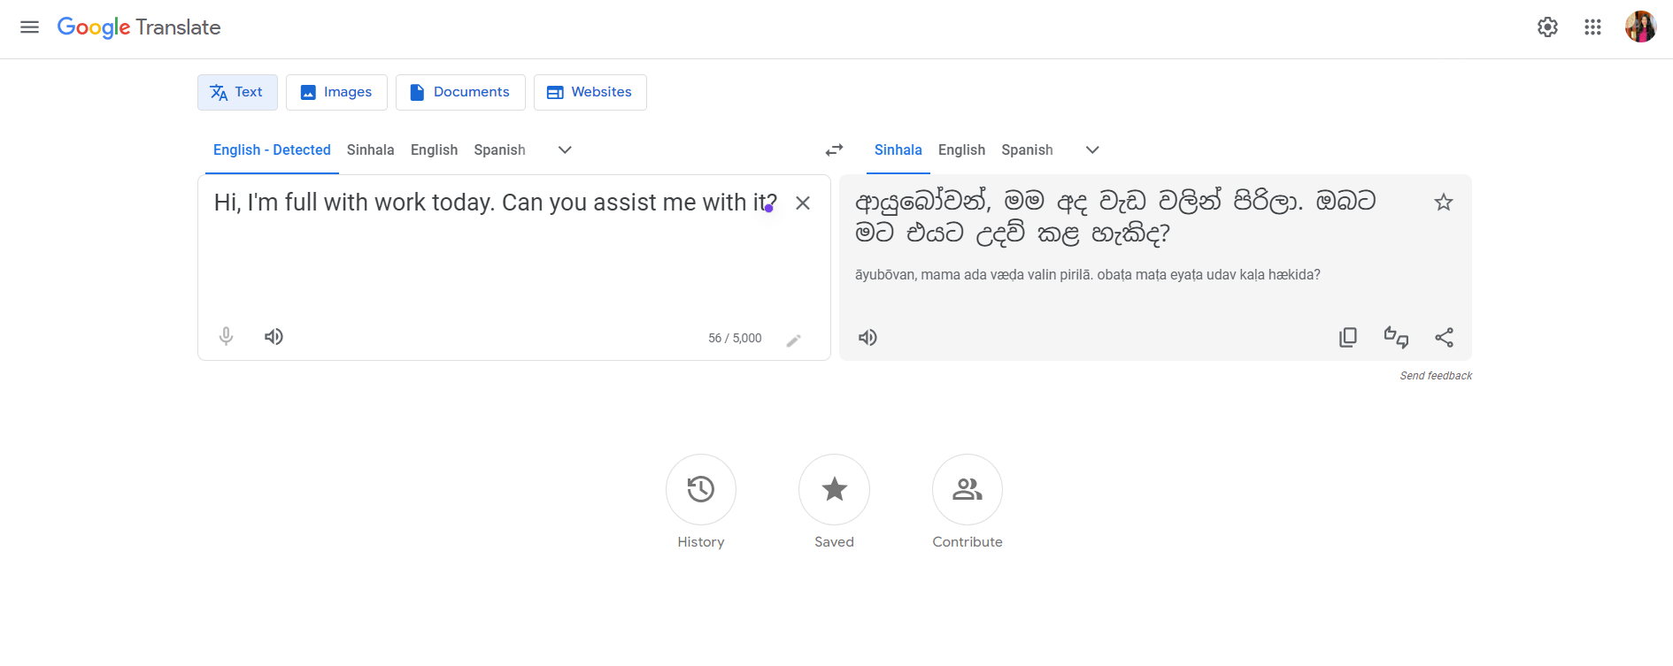

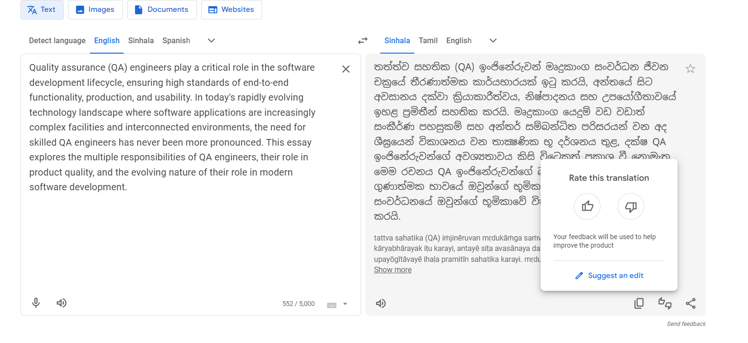

### **Load Testing:**

Performed limited load testing using JMeter to assess the application's performance under simulated load conditions.

Analyzed response times and resource utilization to identify any performance bottlenecks or scalability issues.

Used JMeter Version: apache-jmeter-5.5

**Threads Properties:**

**Number of Threads (users): 1  
Ramp – up period (seconds): 1  
Loop Count: 1**

**Same User on each iteration**

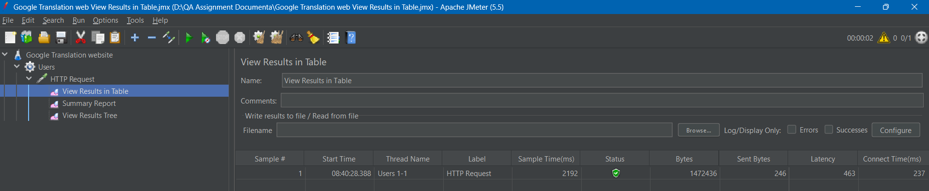

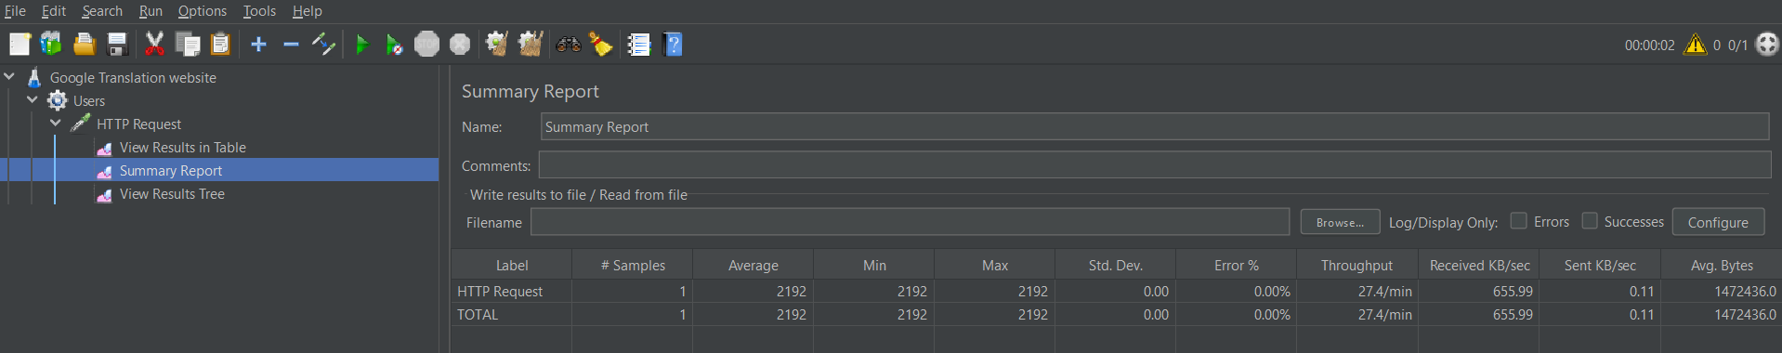

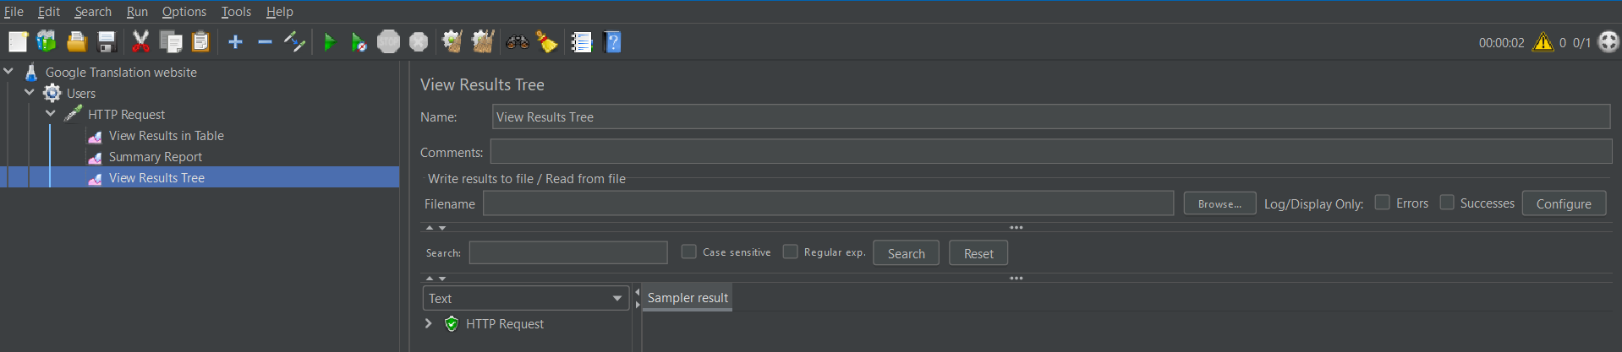

**Number of Threads (users): 10  
Ramp – up period (seconds): 5  
Loop Count: 1**

**Same User on each iteration**

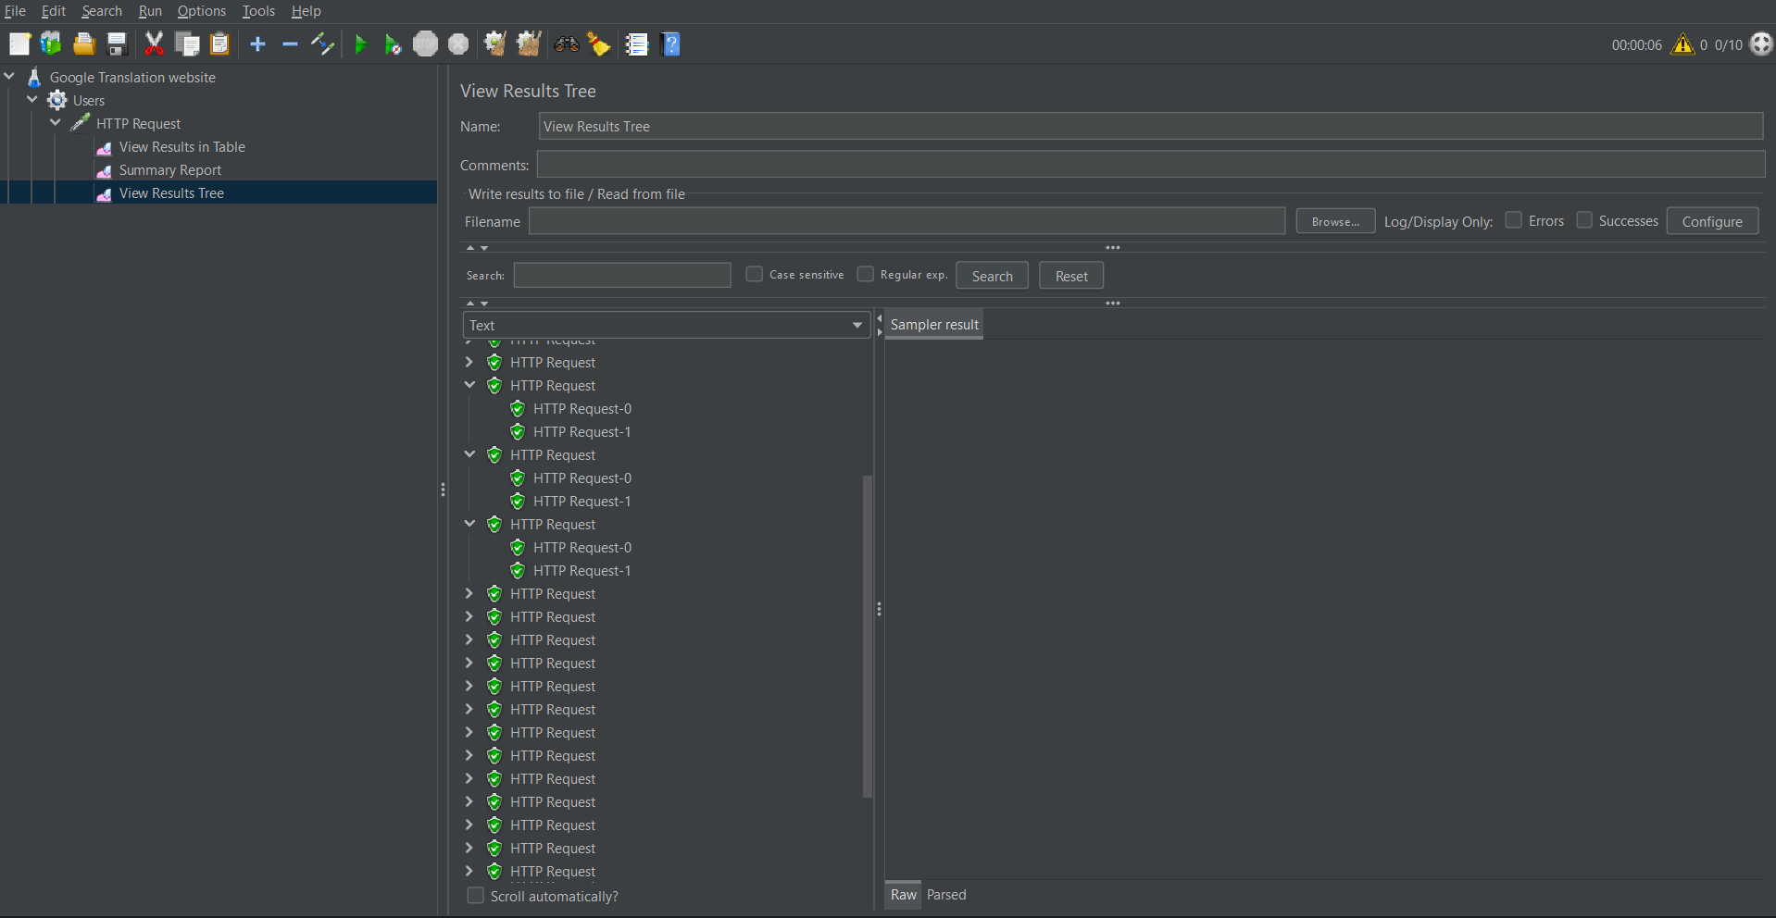

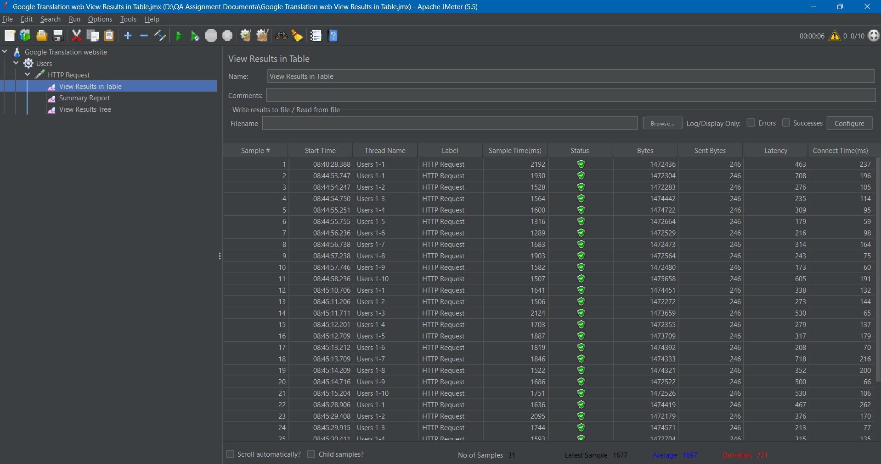

### **Testing Results:**

**Functionality Testing:**

Overall, the web application's functionality performed as expected. Text, image, document, and website translation functions worked reliably, with accurate translations observed in most cases.

**UI Testing:**

The UI was intuitive and user-friendly across different devices, with minor inconsistencies noted in the mobile version.

**Translation Accuracy:**

Translations between English, Sinhala, and Tamil languages were accurate, with occasional discrepancies in complex phrases or sentences.

**Performance Testing:**

Preliminary load testing results indicated satisfactory performance under moderate load conditions. However, further testing may be required to assess scalability and performance under heavier loads.

## **Issues Identified:**

Several UI inconsistencies were observed in the mobile version, including alignment issues and suboptimal layout.

Occasional discrepancies in translation accuracy were noted, particularly with complex or context-dependent phrases.

The load testing revealed no critical performance issues, but additional testing may be needed to validate performance under higher loads.

## **Recommendations:**

Address UI inconsistencies in the mobile version to ensure a seamless user experience across all devices.

Enhance translation accuracy by refining algorithms and incorporating context-aware translation techniques.

Conduct comprehensive performance testing under various load conditions to validate scalability and identify any potential performance bottlenecks.

Implement regular regression testing to ensure that new updates or features do not introduce regressions or affect existing functionality.

# **Conclusion:**

The testing of the Google Translate web application has provided valuable insights into its functionality, usability, and performance. While the application generally performed well, some areas for improvement were identified, particularly in UI consistency and translation accuracy. By addressing these issues and incorporating the recommendations outlined above, the Google Translate web application can continue to provide users with reliable and efficient translation services across different languages and platforms.